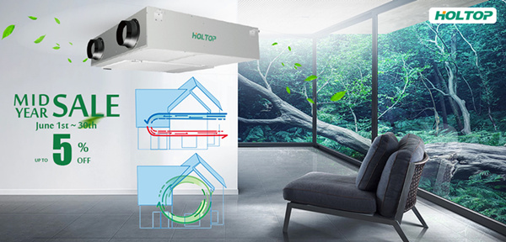

NEW ECO-SLIM Energy Recovery Ventilator ERV with Internal Circulation Function

Product Description

Model | ERVQ-D250-1A1 | ERVQ-D350-1A1
Airflow | 250 m3/h | 350 m3/h
Room area | 50-100 m2 | 70-140 m2

10+ Superior Design 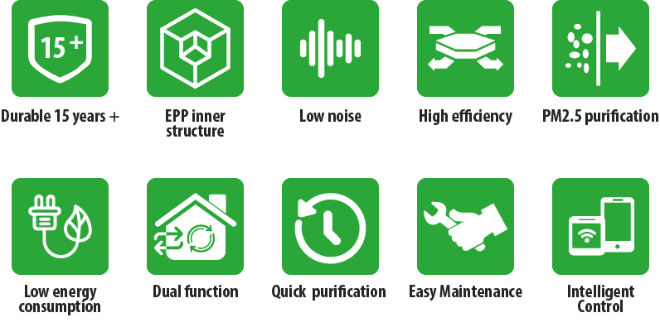

1. High Quality Casing — Alu-Zinc panel

2. EPP Inner Structure
High strength, light weight, sound insulation, environmental protection, odorless;  High performance polymeric material Environment friendly;  Widely used in high-end automobiles and aviation; | 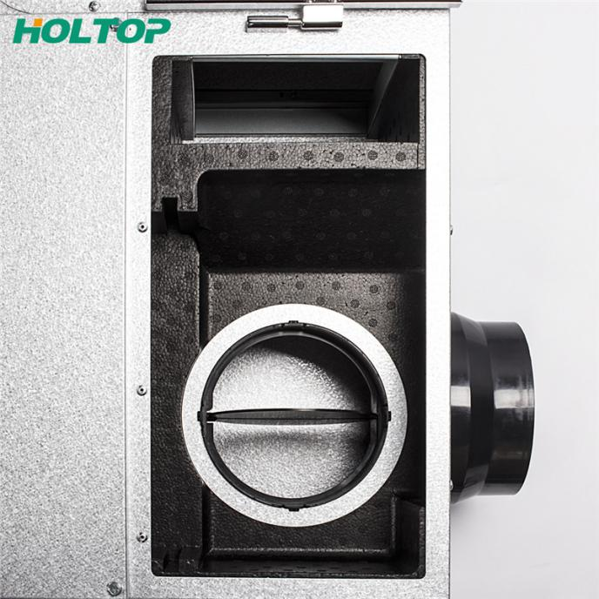

3. Easy Maintenance

Bottom and partial access available Easy to replace the filter;
Less space and easy maintenance;
Every important component can be independently maintained.
(Exhaust fan, supply fan, heat exhcnager)
The filters can be replaced by manually opening the buckle.
(Primary filter, Medium filter, HEPA filter)
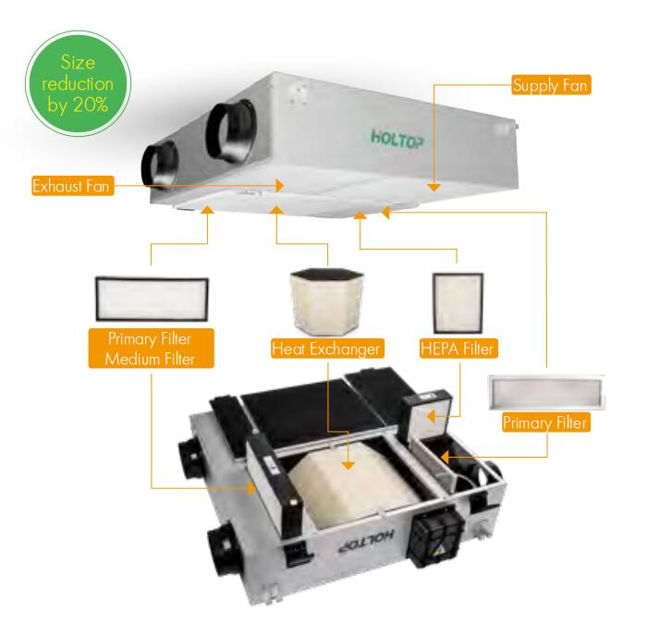

4. Low Noise

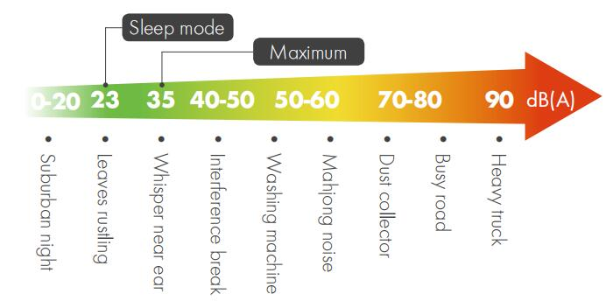

5. PM2.5 Purification
Multiple filters effectively removing PM2.5; The operating room grade filter material with high efficiency up to 99% PM2.5 filtration rate.  Effectively filter dust, PM2.5 haze particles and other harmful substances,  to make air cleaner and healthier. | 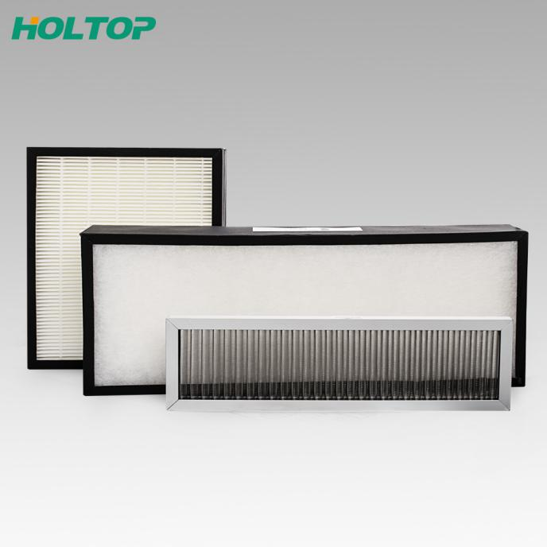
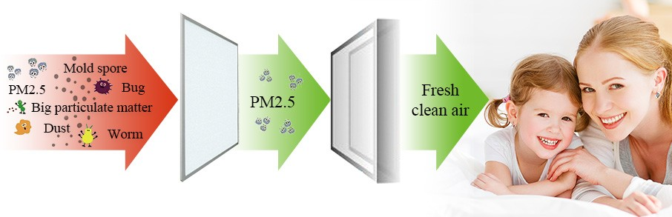

6. Energy-saving DC motor
120Pa E.S.P Satisfy Top / Ground air supply
Powerful DC driven;
Large impeller with more powerful;
16 years of running verification;
Stronger and more stable.

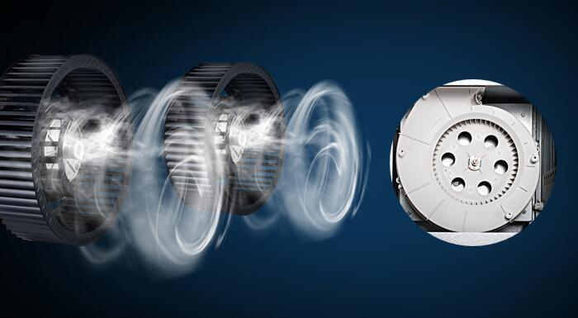

Fresh Air Ventilation+ Internal Circulated Purification

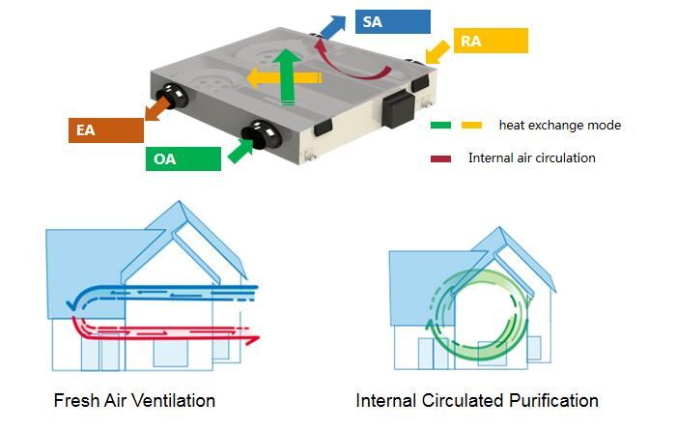

8. Quick removal of harmful particulates in 30 minutes
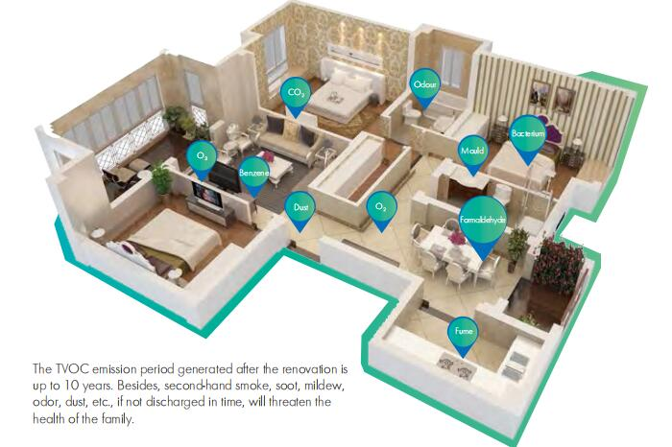

9. High efficiency Counter heat exchanger - low energy consumption
Equipped with HOLTOP new-developed counterflow heat exchanger
• Heat recovery efficiency is up to 86%
• The air supply is completely separated from the exhaust air to avoid cross-contamination
• The latest nano-scale fiber structure ensures temperature and humidity recovery efficiency and reduces energy consumption of air conditioners
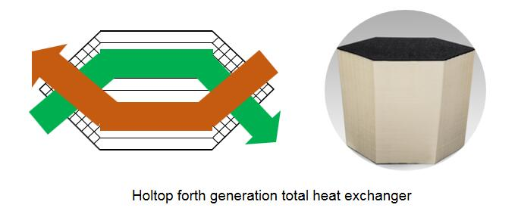
10. Intelligent control system
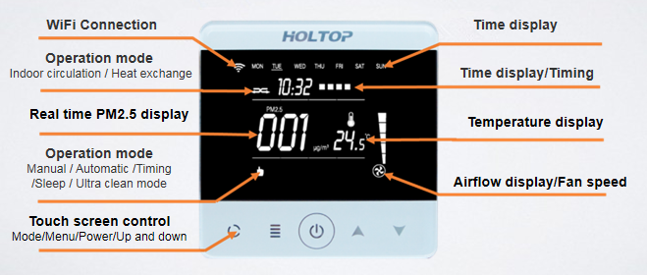

Company Information
Holtop Factory
Holtop is one of the best manufacturer in ERV/HRV, heat exchanger and AHU area in China, founded in 2002, areas covered more than 30,000 square meters, turnover of 2012 is 42 million dollars, we have enthalpy testing lab. for products test. As a leader in energy/heat recovery equipments, we cooperate with more than 30 famous companies who located in Europe, the Middle east, Korea, Southeast Asia, Taiwan, etc. supplied equipment to Beijing Olympic and Shanghai Expo 2010, works together with domestic and international brands like Midea, Haier, Hitachi, etc.
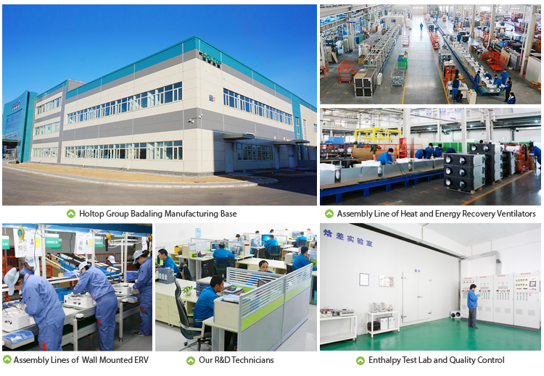
Holtop partner
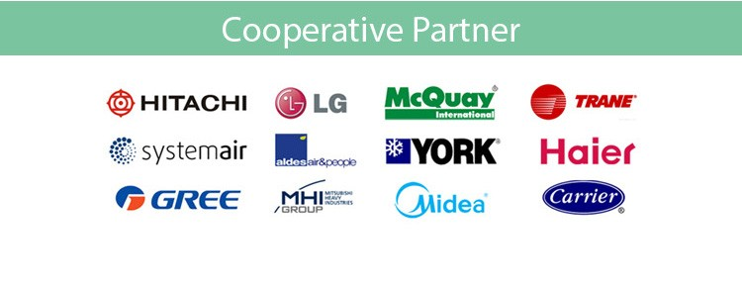
Holtop cooperate with world famous brand or offer OEM service including Hitachi, LG, McQuay, TRANE, Systemair, Aldes, York, Haier, Gree, MHI Group, Midea, Carrier, Dunham-Bush, etc

